Ansible -m ping hostname or all to ping

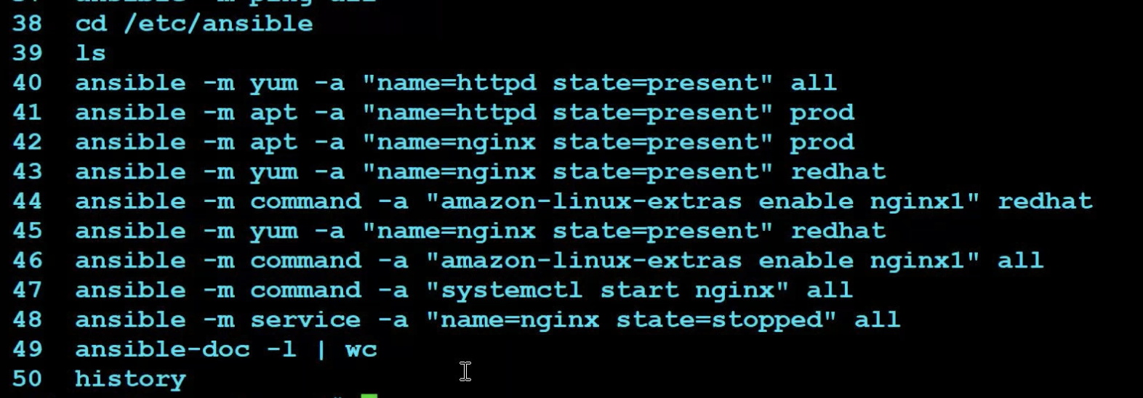

Ansible 25th,26th until playbooks

-m = module -a = argument

The above are called the adhoc commands

* Ansible-doc -l {list all the module} use it with grep to filter
* Ansible-doc -l |wc {to view number of modules}
* Ansible-doc -s “module name” {to read about a module}

Ansible Playbook 26th apr

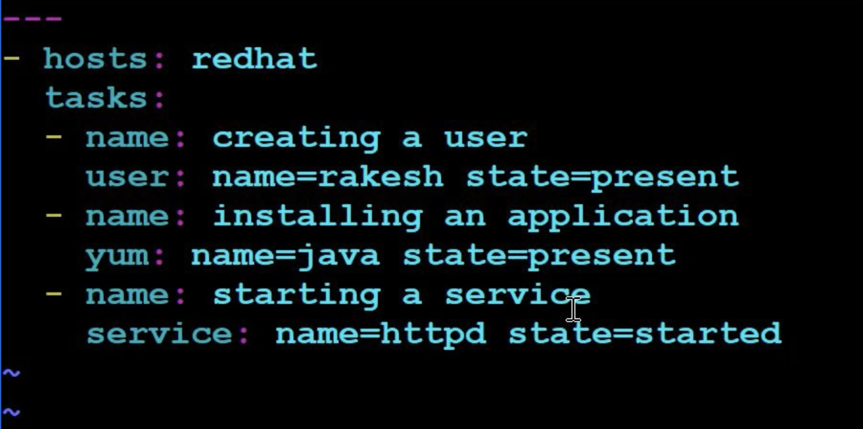

* ansible-playbook playbookname.yml --syntax {to check the syntax}
* ansible-playbook playbookname.yml --check {trail to see what would happen} is not executed but seems to run display the output if ran on servers
* ansible-playbook playbookname.yml {to execute}
* ansible-playbook playbookname.yml –step {to get y/n/continue interactive mode}
* ansible-playbook playbookname.yml –list-tasks {to show list of all the tasks} similar to cat display
* ansible-playbook playbookname.yml –start-at-task=”description of task”{to start from a particular task}

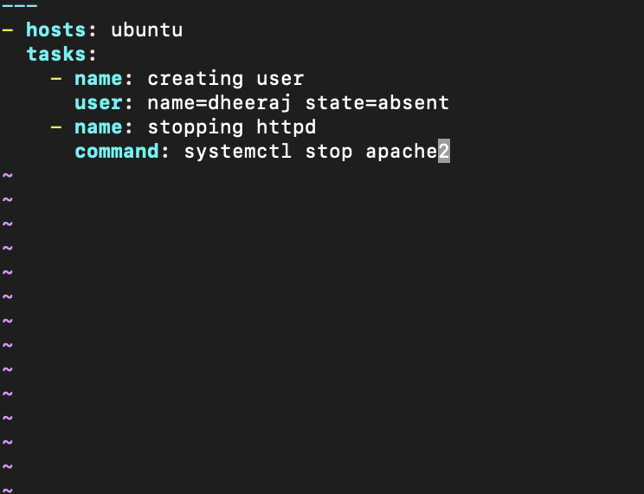

* 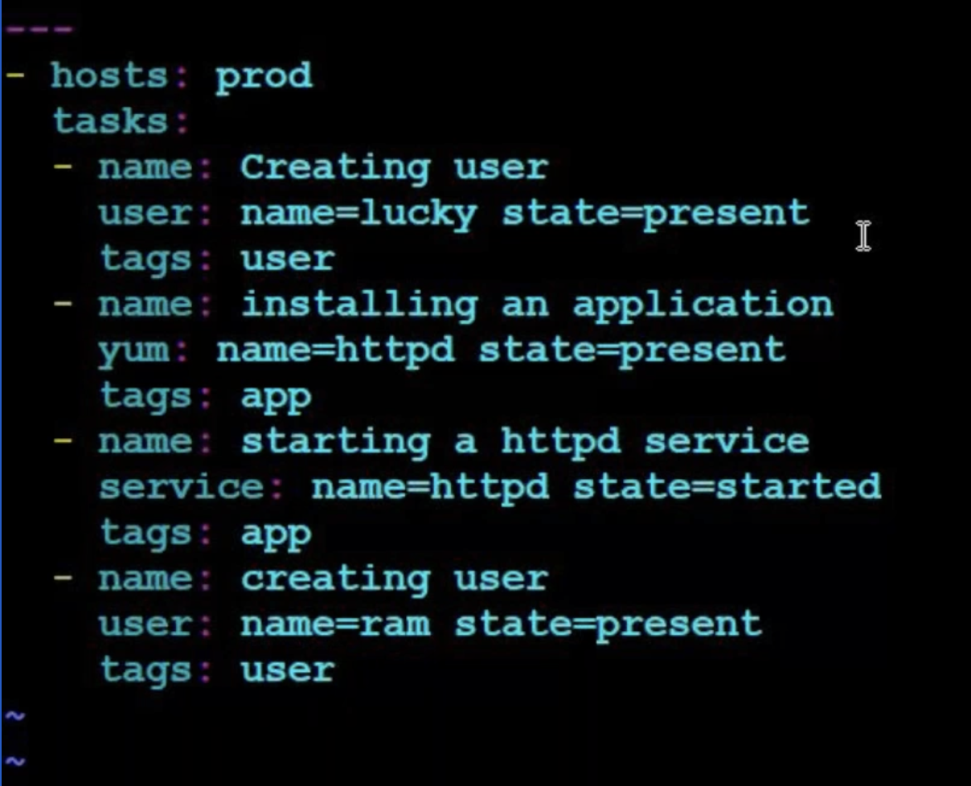

>ansible-playbook playbookname.yml --tags tagname{to execute only only certain group of tags}

* ansible-playbook playbookname.yml –skip-tags tagname {these tags will be skipped}

Using variables to create N tasks with items

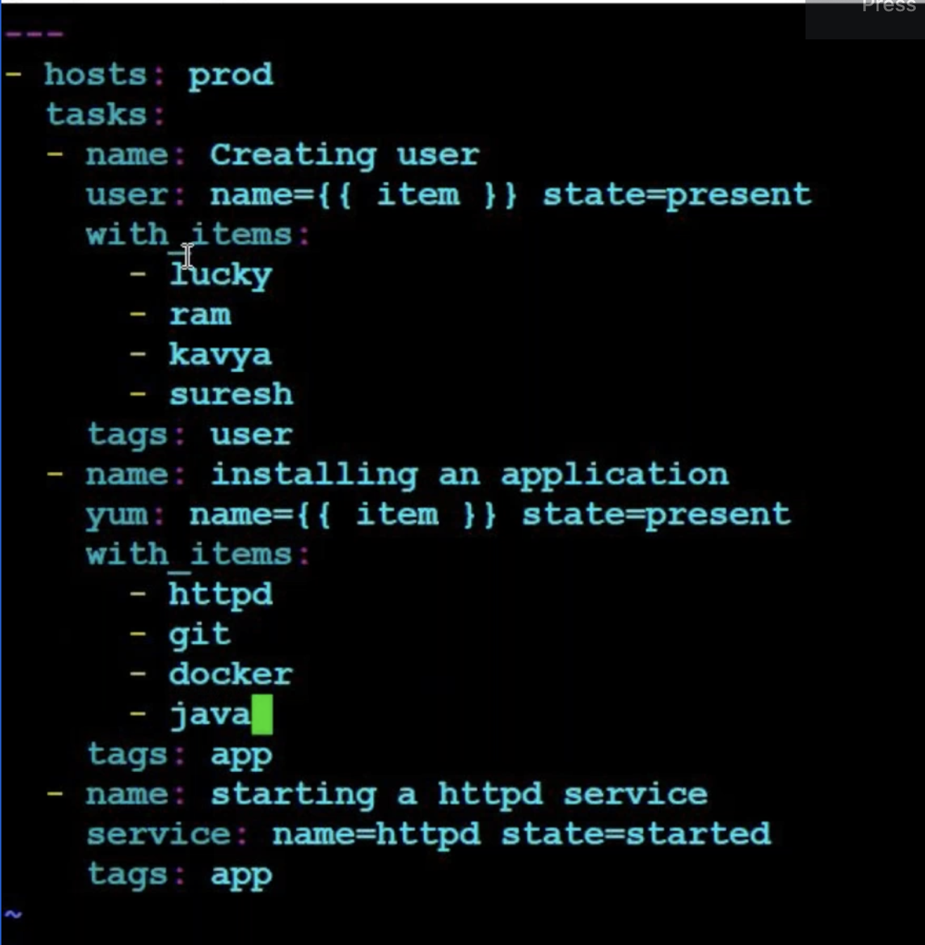

When condition

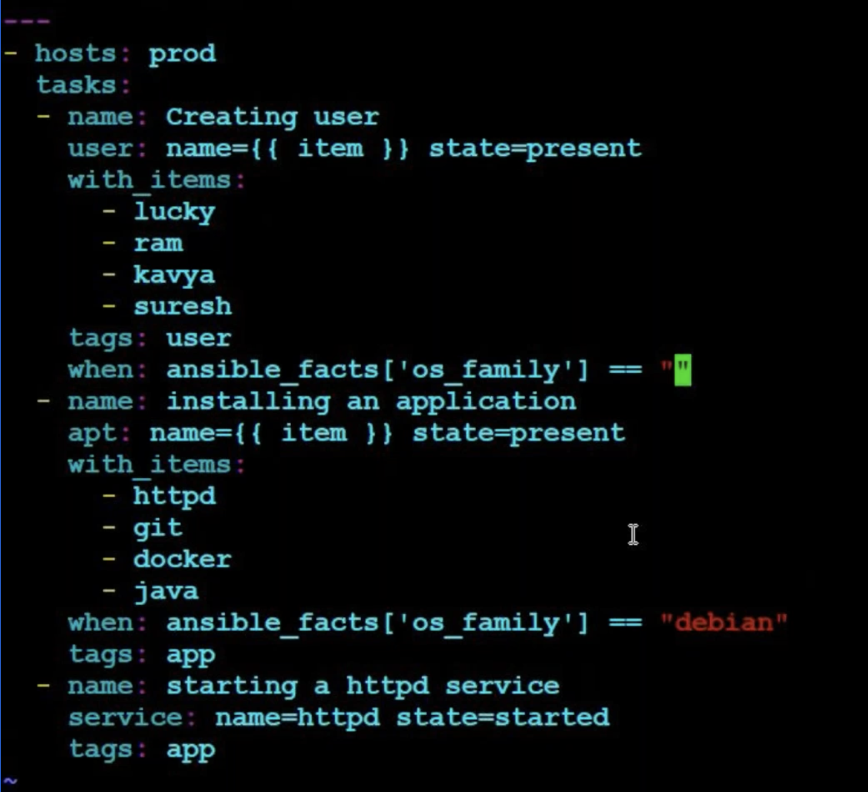

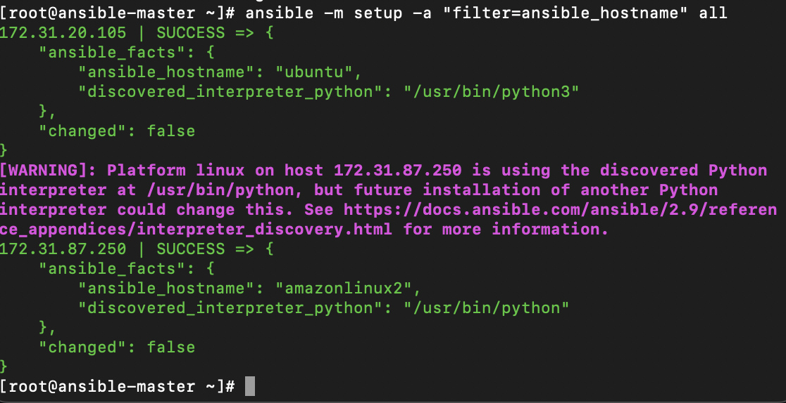

Displaying ansible facts using setup module

* ansible -m setup all
* ansible -m setup -a “filter=ansible_hostname” all

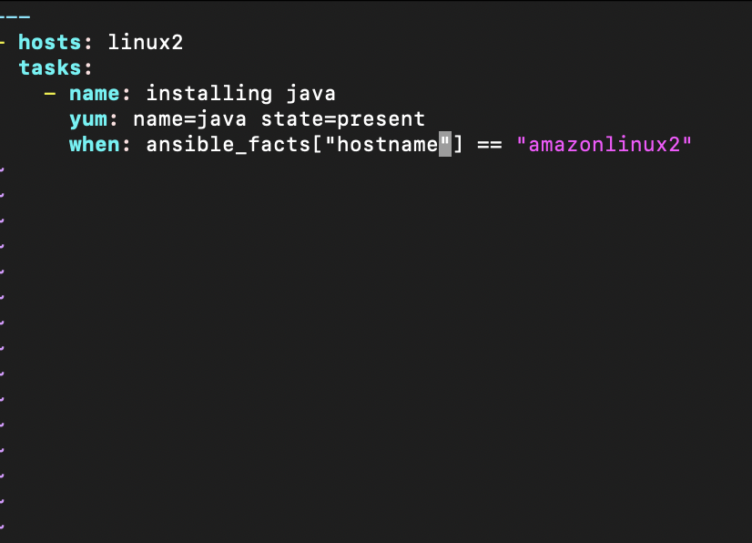

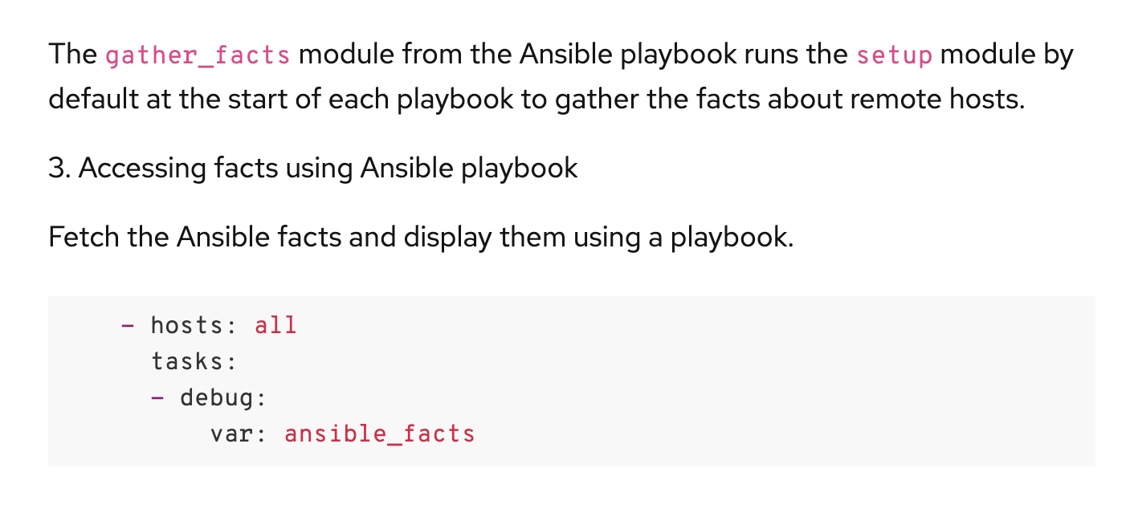 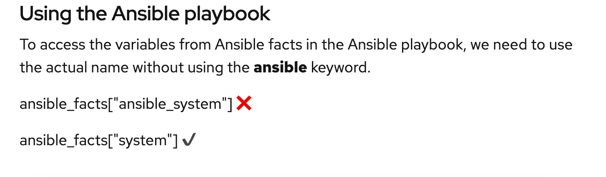

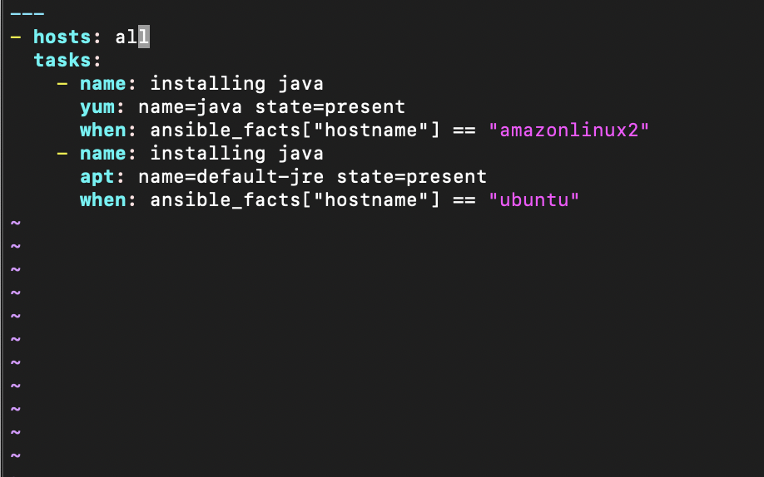

Using httpd.conf file as a template to listen on different ports

(dev:80 test:90)

Copying the httpd conf file into the master ansible to use as a template

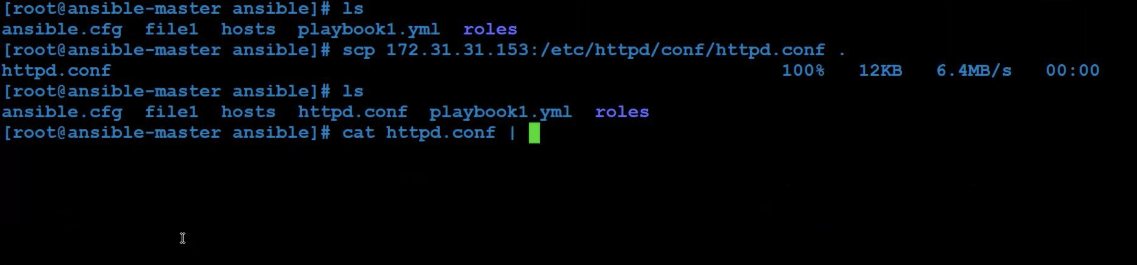

Removing the hard coded 80 value in httpdconf file and assigning a variable {{ portno }} to it { also changed the user value from apache to {{ username }}

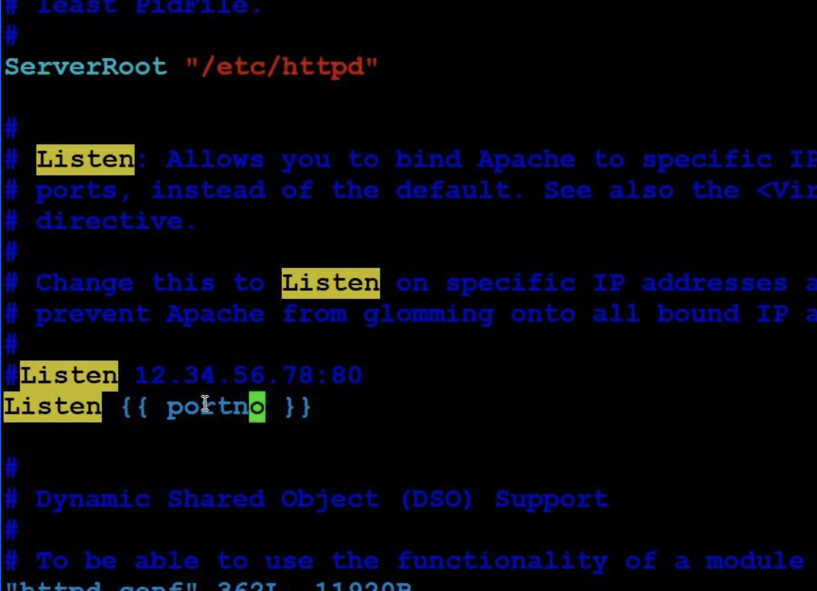

Ansible-master playbook file

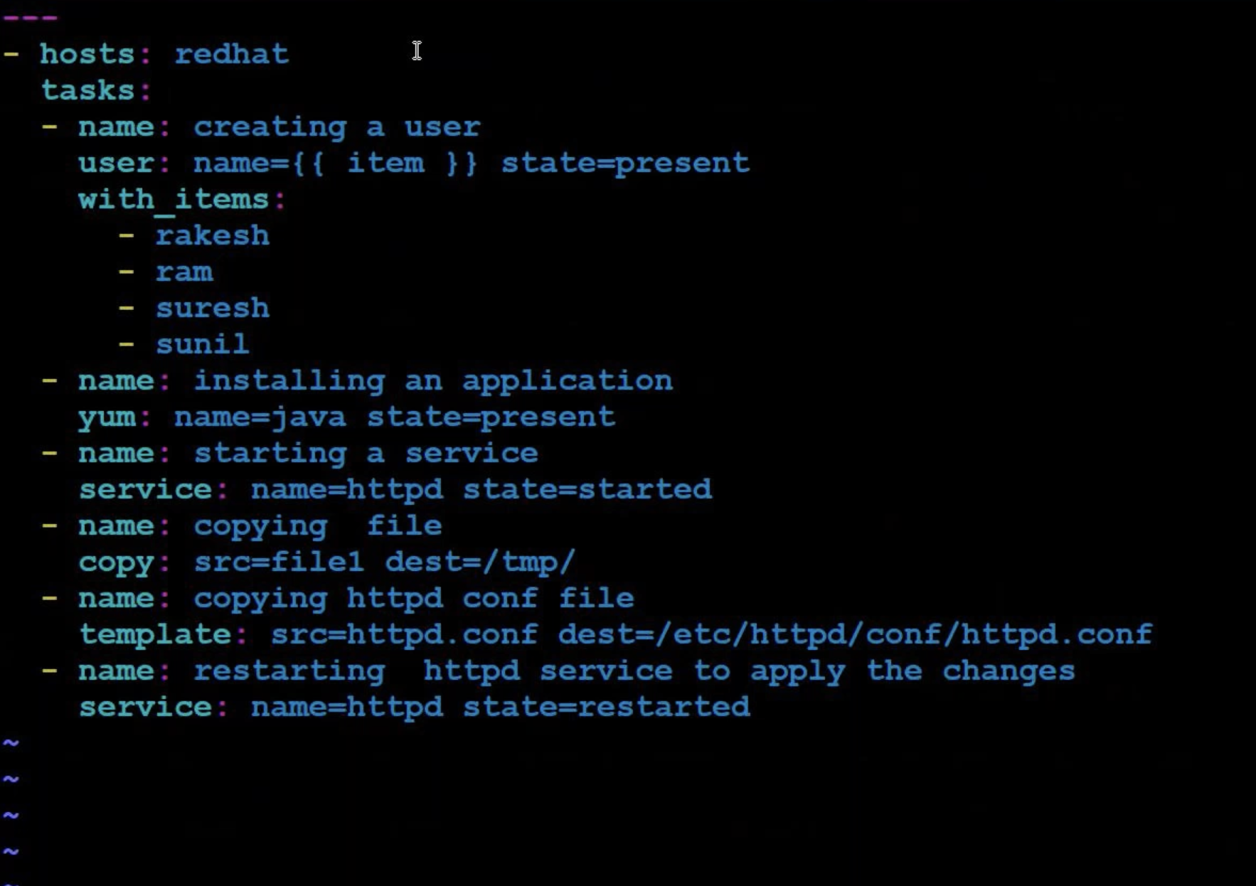

Make sure to create that user you want to mention {tes-ansible}

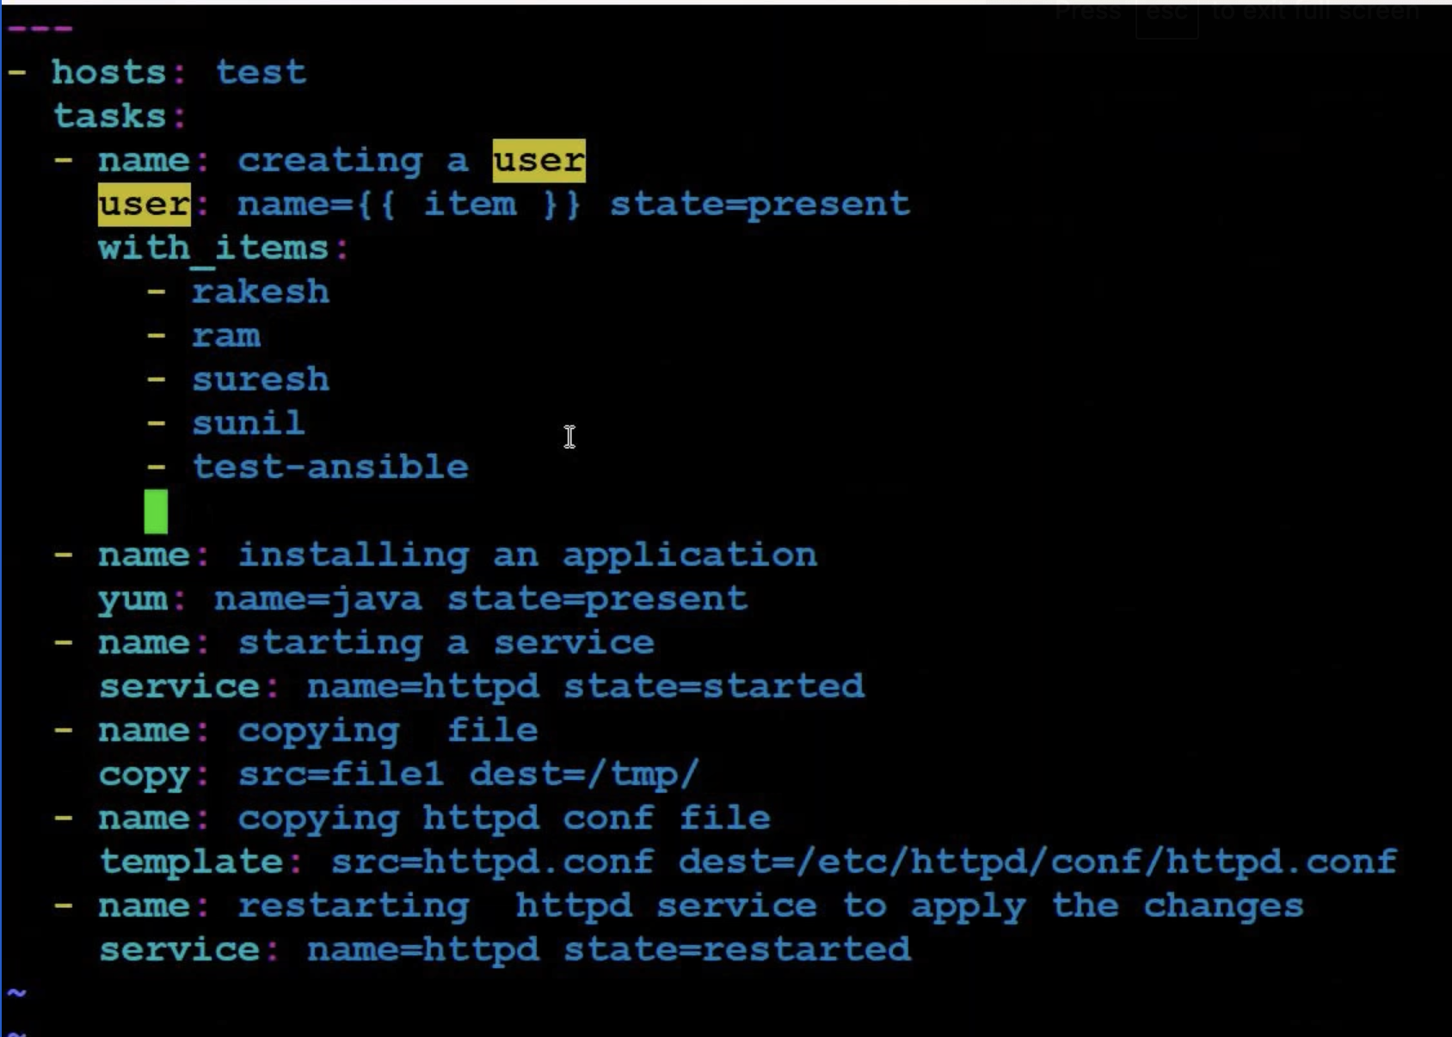

>>ansible-playbook playbook1.yml --extra-vars=”portno=100” --extra-vars=”username=test-ansible”

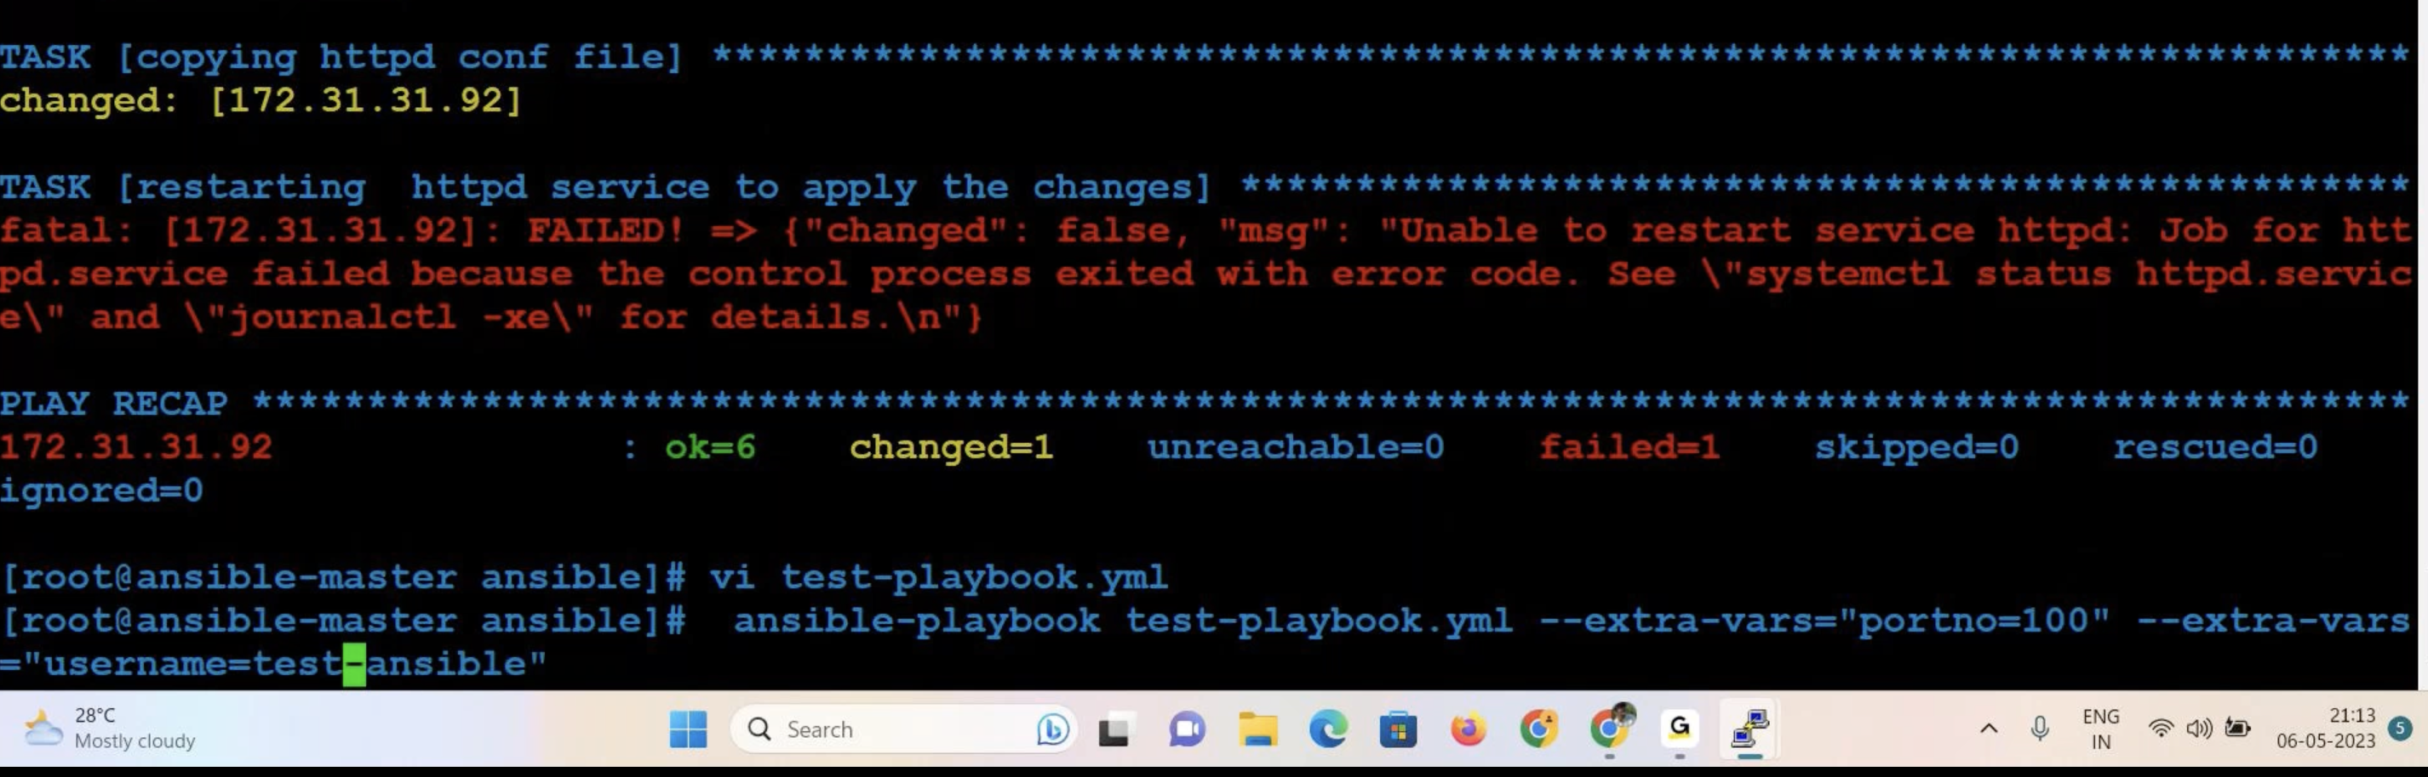

Ignoring_errors: true

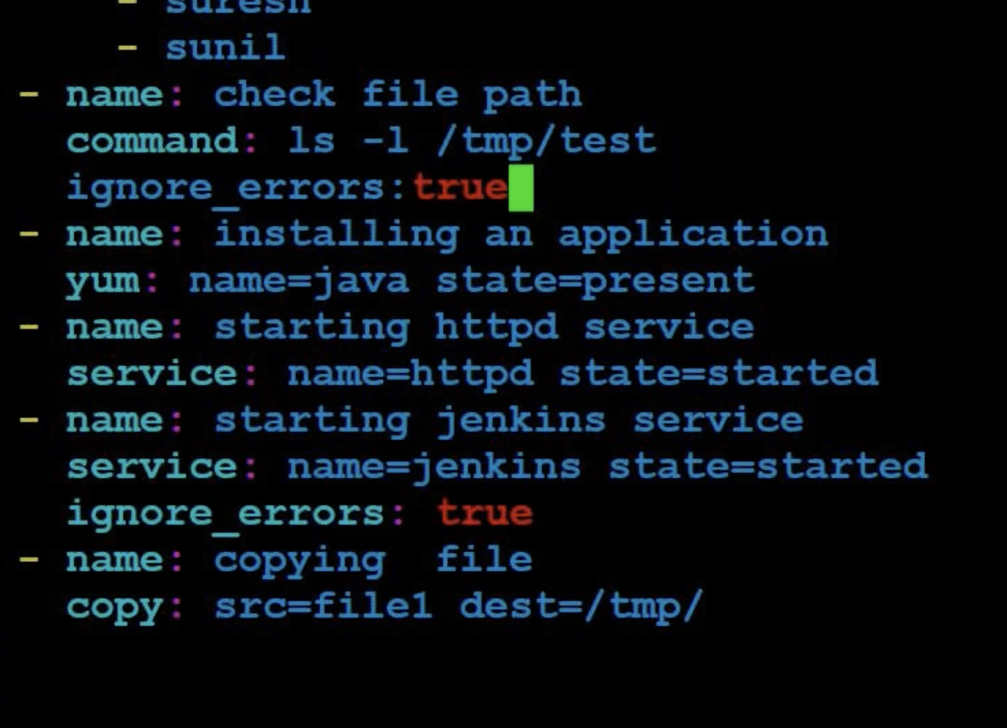

Jenkins Installation using Ansible: <https://medium.com/nerd-for-tech/installing-jenkins-using-an-ansible-playbook-2d99303a235f>

Ansible Use Cases <https://www.linkedin.com/pulse/ansible-automation-real-world-use-cases-vinodha-kumara/>